

SOUTH EASTERN KENYA UNIVERSITY
SCHOOL OF SCIENCE AND COMPUTING

Waste Management System
By
Morris M. Kimanthi
G128/1298/2021
SUPERVISOR: Dr. P. Kasyoka
April, 2025

A research project report submitted to the school of science and computing in partial fulfillment of the requirements for the award of the degree of Bachelor of Information Technology or Bachelor of Science in Computer Science

Declaration
This research project is my original work and has never been presented in any other university for academic use.
Student’s name ……………………
Reg No. …………………………….
SIGNED ……………………………DATE ………………………………..

This research project has been submitted for examination with the approval of the university supervisor
SUPERVISOR
NAME: …………………………………………………………………………
SIGNED ……………………………DATE…………………………………..

Dedication
This project is dedicated to my parents for their unwavering support and encouragement, and to the countless urban residents whose struggles with inefficient waste systems inspired this work.

Acknowledgment
I sincerely thank my supervisor for his expert guidance, constructive criticism, and continuous support throughout the course of this project.
I also appreciate the valuable feedback from my classmates and the cooperation of waste management personnel who participated in my research. Special thanks to my family and friends for their patience and encouragement throughout this journey.

Abstract
The rapid rate of urbanization has created significant challenges in waste management, with traditional systems becoming increasingly inefficient. This project aimed to develop a digital waste management system to improve waste collection, monitoring, and citizen engagement in urban areas. The system integrates real-time waste tracking, route optimization for collection vehicles, and a user-friendly interface for residents to schedule pickups and monitor services.
An experimental research design was adopted, with system development following the Waterfall Model. Data was collected through stakeholder interviews, document analysis, and user surveys targeting waste management companies and urban residents. The system was developed using HTML, CSS, JavaScript, php, and MySQL, and included modules for user management and payment processing.
Findings indicate that integrating route optimization and real-time waste monitoring significantly enhances the efficiency of waste collection operations. User feedback highlighted the importance of notifications, scheduling options, and transparency in service delivery. The system was validated through user acceptance testing and showed high usability and functionality.
The project concludes that a digital approach to waste management not only improves operational efficiency but also fosters active citizen participation and environmental sustainability. Recommendations are made for future integration with municipal services and expansion to include AI-based predictive analytics.

Definition of Terms
- Digital Waste Management System – A web-based platform developed to streamline waste collection, tracking, and payment processes.
- Route Optimization – A system feature that calculates the most efficient paths for waste collection trucks, saving fuel and time.
- User Authentication – A login process that ensures only registered users (admin, staff, residents) access appropriate parts of the system.
- Smart Bin – A waste bin integrated with sensors to monitor waste levels and notify collection teams.
- User Role – The defined level of access in the system depending on whether the user is an admin, staff, or resident.

List of Abbreviations/Acronyms
Abbreviation | Full Form
IoT | Internet of Things
UI | User Interface
ERD | Entity Relationship Diagram
DFD | Data Flow Diagram
SQL | Structured Query Language
UAT | User Acceptance Testing

Table of Contents
Declaration i
Dedication ii
Acknowledgment iii
Abstract iv
Definition of Terms v
List of Abbreviations/Acronyms vi
List of Tables ix
List of Figures x
CHAPTER 1: INTRODUCTION 1
1.1 Background of the Study 1
1.2 Problem Statement 3
1.3 Objectives 3
General Objective 3
Specific Objectives 3
1.4 Research Questions 3
1.5 Hypotheses 3
1.6 Justification 3
1.7 Scope of the Study 4
CHAPTER 2: LITERATURE REVIEW 5
2.1 Introduction 5
2.2 Review of Theoretical Literature 5
2.3 Review of Analytical Literature 6
2.4 Research Gap 6
CHAPTER 3: RESEARCH DESIGN AND METHODOLOGY 8
3.1 Introduction 8
3.2 Research Design 8
3.3 System Development Approach 9
Requirements Analysis 9
3.4 Population and Sampling 10
3.5 Data Collection Methods 10
3.6 Data Analysis Methods 12
CHAPTER 4: RESEARCH DESIGN AND METHODOLOGY 14
4.1 Introduction 14
4.2 Presentation of Data Analysis 14
4.3 Summary of Data Analysis 14
4.4 System Analysis 14
4.5 System Specification 14
4.6 System Design 15
4.6.1 Data Flow Diagram (DFD) 15
4.6.2 Use Case Diagram 17
4.6.3 Interface Design 17
4.6.4 Database Design 17
4.6.5 Reports 20
CHAPTER 5: SUMMARY OF FINDINGS, CONCLUSIONS AND RECOMMENDATIONS 22
5.1 Introduction 22
5.2 Summary of Findings 22
5.3 Conclusions 22
5.4 Recommendations 23
References 24
Appendices 25

List of Tables
Table 1 users table 18
Table 2 collectors table 18
Table 3 orders table 18
Table 4 trucks table 19
Table 5 feedback table 19

List of Figures
Figure 1 dfd 17
Figure 2 user case diagram 17
Figure 3 registration form 26
Figure 4 user dashboard 26
Figure 5 collector’s dashboard 27
Figure 6 admin dashboard 27
Figure 7 Gannt chart 30

CHAPTER 1: INTRODUCTION

1.1 Background of the Study
Efficient waste management is a critical component of urban sustainability and environmental protection. As cities expand and populations grow, the amount of waste generated increases exponentially. Urbanization has led to higher consumption rates, increased industrial activities, and changing lifestyles, all of which contribute to a rise in solid waste production. Unfortunately, many waste management systems in developing and developed cities rely on outdated, inefficient, and labor-intensive processes that fail to meet modern waste disposal demands.
Traditional garbage collection methods primarily involve scheduled pickups, where waste collection trucks follow predetermined routes regardless of whether bins are full or not. This leads to operational inefficiencies, unnecessary fuel consumption, and increased labor costs. Furthermore, in many urban areas, waste collection services are inconsistent, leaving some communities underserved while others experience excessive waste accumulation. This inconsistency results in uncollected garbage piling up on streets, clogging drainage systems, and creating breeding grounds for pests and diseases. Poorly managed waste contributes to environmental pollution, leading to air, soil, and water contamination, which poses significant health risks to humans and animals.
Moreover, manual record-keeping in waste collection companies often results in data inaccuracy, making it difficult to track service efficiency, payments, and waste disposal patterns. Without a streamlined system, it becomes challenging for municipalities and private waste management companies to monitor collection activities, optimize routes, or efficiently allocate resources. The lack of an organized digital system leads to revenue losses, poor accountability, and difficulties in enforcing waste management policies.
The Role of Digital Transformation in Waste Management
The integration of digital technologies into waste management has emerged as a viable solution to these challenges. Smart waste management systems leverage information and communication technology (ICT) to optimize garbage collection operations, improve service delivery, and enhance environmental sustainability. These systems include features such as:
Real-time Monitoring and Tracking: GPS-enabled tracking systems allow authorities to monitor garbage collection trucks in real time, ensuring timely and efficient waste disposal. This prevents delays, reduces fuel consumption, and helps allocate resources more effectively.

Automated Scheduling and Route Optimization: Traditional fixed-route collection systems often lead to inefficiencies, where garbage trucks visit locations that may not require immediate service. Smart waste management systems use data analytics and artificial intelligence to determine the most efficient routes based on real-time waste levels, significantly reducing operational costs and carbon emissions.
Citizen Engagement through Digital Platforms: Many modern waste management solutions integrate mobile applications or web-based platforms that allow residents to report overflowing bins, request waste collection services, and receive updates on scheduled pickups. This enhances community participation and ensures that waste management services are more responsive to citizens' needs.
Improved Data Management and Analytics: Digital systems replace traditional manual record-keeping with automated data storage, making it easier to track payment records, monitor waste disposal trends, and generate reports for policy-making. With accurate data, authorities and private companies can make informed decisions, allocate resources efficiently, and improve overall waste management performance.
Cashless and Transparent Payment Systems: Many municipalities and private garbage collection companies face revenue collection challenges due to manual billing processes. A web-based system can integrate digital payment options such as mobile money, credit card transactions, and automated invoicing, reducing revenue leakages and improving financial accountability.
The Need for a Web-Based Garbage Collection Management System
A well-developed garbage collection management system can significantly improve waste disposal operations. By digitalizing the process, waste collection companies can enhance efficiency, reduce costs, and provide better services to residents. A web-based system ensures smooth communication between service providers, clients, and municipal authorities, leading to better coordination of waste collection activities.
In conclusion, inefficient waste management remains a pressing issue in many urban areas, leading to environmental degradation, health risks, and economic losses. Implementing a digital garbage collection management system offers a modern solution to these challenges by enhancing efficiency, reducing operational costs, and promoting sustainable urban living. By leveraging technology, waste collection services can be transformed into a more responsive, data-driven, and environmentally conscious system that benefits both service providers and the communities they serve.

1.2 Problem Statement
Many garbage collection companies still rely on manual record-keeping, leading to issues such as:
Inefficiency in waste collection: Trucks follow fixed schedules regardless of actual waste levels, leading to unnecessary fuel consumption.
Data inaccuracy: Manual tracking of clients and payments can result in errors.
Lack of citizen engagement: Residents struggle to find proper waste disposal points.
Limited resource utilization: Without optimized routes, resources are wasted, and coverage is incomplete.

1.3 Objectives

General Objective
Develop a web-based system to manage garbage collection operations efficiently.

Specific Objectives
Implement user authentication for administrators and collectors.
Enable client and waste category management.
Facilitate payment collection and reporting.
Improve citizen participation by integrating a smart bin locator.

1.4 Research Questions
How can digital systems improve waste management efficiency?
What are the challenges in transitioning from manual to digital systems?
How can technology optimize garbage collection routes?

1.5 Hypotheses
- The implementation of digital systems significantly improves the efficiency of waste management operations.
- Transitioning from manual to digital systems presents notable challenges such as staff resistance, cost of implementation, and data migration issues.
- Technological solutions, such as route optimization algorithms and real-time monitoring, can effectively reduce operational costs and improve garbage collection efficiency.

1.6 Justification
Implementing a smart garbage collection system will:
Reduce operational costs for waste collection companies.
Improve efficiency and accuracy in record-keeping.
Enhance environmental sustainability by reducing pollution.
Increase citizen participation in proper waste disposal.

1.7 Scope of the Study
This study focuses on developing a PHP-based garbage collection system covering:
User management: Administrator and collector roles.
Client management: Customer registration and waste tracking.
Payment processing: Digital payment integration for garbage collection fees.

CHAPTER 2: LITERATURE REVIEW

2.1 Introduction
The escalating challenges in waste management, driven by rapid urbanization, population growth, and technological advancements, necessitate innovative solutions that integrate digital technologies (Sesay, 2025). Traditional waste collection methods, which rely on routine schedules and manual processes, have proven inefficient, leading to overflowing bins, environmental pollution, and increased operational costs. A significant issue in waste management is the lack of real-time data, which results in inefficient collection routes, delays, and uncoordinated efforts among stakeholders ((Kerdlap et al., 2029). Without accurate tracking and monitoring mechanisms, municipal authorities struggle to allocate resources effectively, leading to either excessive or inadequate waste collection services in different areas. Therefore, the adoption of technology-driven approaches, such as the Internet of Things (IoT), artificial intelligence (AI), and cloud computing, has become essential for sustainable urban waste management (Wang et al., 2021).
The integration of digital technologies into waste management has shown great potential in improving efficiency and sustainability. IoT-enabled smart bins can monitor waste levels and notify collection authorities when they are full, thereby reducing unnecessary trips and fuel consumption (Rodriguez & Li, 2023). Geographic Information Systems (GIS) and AI-based analytics allow for predictive modeling and route optimization, ensuring that waste collection resources are used effectively. Additionally, mobile applications enhance communication between waste service providers and residents, allowing citizens to report waste-related issues and receive real-time updates on collection schedules (Ahmad et al., 2021). Despite these advancements, challenges such as high implementation costs, public adoption barriers, and technical limitations persist, highlighting the need for further research and development in integrating these technologies into existing waste management frameworks (Kerdlap et al., 2019).

2.2 Review of Theoretical Literature
Information Systems Theory: This theory posits that integrating technology into organizational processes enhances efficiency and decision-making. In waste management, information systems enable real-time data collection, processing, and dissemination, facilitating optimized operations and resource allocation. For instance, IoT-enabled sensors can monitor waste bin levels, transmitting data to central systems that schedule collections based on actual need rather than fixed schedules, thus improving efficiency and reducing costs. ​
Sustainability Theory: This framework emphasizes meeting present needs without compromising future generations' ability to meet theirs. Incorporating digital solutions into waste management aligns with sustainability goals by promoting efficient resource use, reducing environmental impact, and supporting circular economy principles. For example, digital platforms can facilitate the tracking and recycling of electronic waste, ensuring valuable materials are recovered and reused, thereby minimizing environmental harm. ​

2.3 Review of Analytical Literature
The adoption of digital technologies has significantly transformed waste management practices, introducing smart bins, IoT-based waste tracking, and mobile applications that enhance efficiency and sustainability. Smart bins equipped with sensors monitor fill levels in real time and communicate with collection services to optimize pickup schedules, reducing unnecessary trips and preventing overflow (Singh et al., 2023). IoT-based tracking systems provide detailed waste generation data, enabling municipalities to allocate resources efficiently and adjust collection routes based on demand (Hassan & Kumar, 2024). Additionally, mobile applications empower citizens by offering features such as waste pickup scheduling, recycling information, and illegal dumping reporting, fostering greater public participation in environmental conservation efforts (Chowdhury & Ali, 2024).
Despite these advancements, several challenges hinder the widespread implementation of digital waste management systems. High infrastructure costs, including the installation of smart bins, IoT networks, and cloud-based data storage, pose significant financial barriers, particularly for municipalities with limited budgets (Ahmed & Smith, 2023). Public adoption requires behavioral shifts and adequate training for both citizens and waste management personnel to effectively use digital platforms (Garcia & Lee, 2024). Additionally, interoperability issues among different waste management technologies complicate data integration, leading to inefficiencies in operations (Hernandez & Chen, 2024). Cybersecurity concerns also pose risks, as digital systems handling sensitive waste collection data must be safeguarded against potential cyber threats (Rodriguez et al., 2024). Addressing these challenges requires strategic investments, policy support, and public awareness initiatives to ensure the effective adoption and long-term success of digital waste management solutions.

2.4 Research Gap
While existing systems have made strides in optimizing waste collection and monitoring, there is a notable lack of integrated solutions that combine route optimization with active citizen engagement. Many current waste management solutions primarily focus on operational efficiency, such as reducing fuel consumption and optimizing garbage truck routes using IoT and AI-driven algorithms (Miller & Zhao, 2023). However, these systems often overlook the crucial role of public participation in waste disposal and segregation, which directly impacts the effectiveness of collection efforts (Hernandez & Green, 2024). Without a mechanism for real-time interaction between waste collection authorities and the community, issues such as illegal dumping, inconsistent waste disposal habits, and public unawareness about waste categorization persist (Garcia & Chen, 2024). Implementing a holistic system that merges route optimization with citizen engagement would not only improve collection efficiency but also promote responsible waste disposal behaviors among residents.
Addressing this gap could lead to more sustainable and efficient waste management practices, fostering collaboration between service providers and the community. For instance, mobile applications and web-based platforms could enable citizens to report full bins, schedule pickups, and receive updates on collection times, thereby improving service accessibility and responsiveness (Kumar & Patel, 2024). Additionally, incentivizing proper waste disposal through reward-based programs or gamification strategies could encourage greater community participation in recycling and composting efforts (Rodriguez & Li, 2023). Governments and private waste management companies must also consider educational initiatives that raise awareness about the benefits of waste segregation and responsible disposal. By integrating these elements, a comprehensive system could enhance waste collection logistics while promoting a culture of environmental responsibility, ultimately contributing to the sustainability goals of modern smart cities (Ahmed & Smith, 2023).

CHAPTER 3: RESEARCH DESIGN AND METHODOLOGY

3.1 Introduction
This chapter provides a comprehensive outline of the research methodology employed in the development and evaluation of the proposed digital garbage management system. The methodology serves as a systematic framework that ensures the research objectives are met effectively and efficiently. It outlines the key components, including the research design, system development approach, population and sampling methods, data collection techniques, system design framework, and the various testing and validation procedures implemented throughout the research process. This methodology is designed to offer a structured approach to both the design and implementation phases, ultimately ensuring the system addresses the existing inefficiencies in the waste management sector.
A well-defined research methodology is essential for guiding the development of the digital waste management system, ensuring the system’s functionality, usability, and effectiveness are evaluated rigorously. The aim is to create a solution that not only solves existing problems in waste collection but also provides a roadmap for future innovations in waste management practices. By adhering to this structured approach, the methodology guarantees that the developed system meets the practical needs of waste collection companies and urban residents while ensuring the integration of new technologies into the waste management process.

3.2 Research Design
The study adopts an experimental research design that emphasizes system development, rigorous testing, and real-world evaluation. The experimental design allows for the testing of various system components in practical settings, offering an opportunity for iterative refinements based on continuous feedback from end-users. This iterative process ensures that the system is adaptable and able to meet the dynamic challenges of modern waste management. Additionally, the design-science paradigm is followed, which integrates problem identification, artifact development, and evaluation into the research methodology. This approach enables the researcher to identify specific issues within the waste management process, create a technological solution (i.e., the digital garbage management system), and evaluate its effectiveness in real-world scenarios.
The design-science paradigm is particularly suited for addressing complex, real-world problems through the development of innovative technological artifacts. By combining theory with practical implementation, the research methodology not only aims to address the specific needs of waste management but also contributes to the broader field of digital system development. The iterative and experimental nature of the research ensures that the solution evolves in alignment with the needs and expectations of stakeholders.

3.3 System Development Approach
The development of the digital garbage management system follows the Waterfall Model, which provides a structured and sequential approach to software development. The Waterfall Model is particularly effective in this context as it ensures that each phase of development is thoroughly completed before moving to the next, thereby reducing errors and increasing system reliability. The Waterfall Model consists of the following phases:
Requirements Analysis
This phase involves identifying the specific needs of waste collection companies, urban residents, and other stakeholders. It involves gathering data about existing waste management practices and challenges, and translating these into system requirements.
System Design
In this phase, the architecture of the system is developed, including database design, system flow diagrams, and user interface design. A detailed technical blueprint of the system is created, ensuring all components are well-defined.
Implementation
During this phase, the actual coding and programming of the system take place. Modules for user management, waste tracking, payment processing, and other key features are developed and integrated.
Testing
A series of testing methods are used to ensure that each module of the system functions as expected. This includes unit testing, integration testing, and system testing to identify and resolve any bugs or performance issues.
Deployment
Once testing is completed, the system is deployed in a real-world environment. The system is made available to waste management companies and urban residents for actual use, and its performance is monitored.
Maintenance
Post-deployment, the system is maintained to ensure it continues to meet the needs of users. This includes addressing any issues that arise, updating the system for new features, and ensuring its long-term sustainability.
By adhering to the Waterfall Model, the research ensures that each stage of the system development process is carefully managed and executed, with a focus on minimizing errors and ensuring that the final product is both functional and user-friendly.

3.4 Population and Sampling
The research focuses on two key groups:
Waste Collection Companies: These are the organizations responsible for managing the logistics of waste collection, including scheduling and routing. Waste collection companies are the primary users of the system, utilizing it for route optimization, client management, waste tracking, and data analytics.
Urban Residents: The system is also designed for citizens who generate waste and interact with waste collection services. Urban residents will use the system to request waste collection, track the status of their waste, and engage in recycling efforts.

The purposive sampling technique is employed to select participants who have direct involvement in waste management operations. This method ensures that only those with relevant knowledge and experience in waste management processes are included in the study, thus ensuring that feedback and evaluations are based on informed perspectives. The selection of participants from both waste management companies and urban residents ensures a well-rounded understanding of the system’s requirements and effectiveness.

3.5 Data Collection Methods
Stakeholder Interviews
Structured interviews are conducted with waste management professionals, municipal officials, and waste collection personnel to gather insights into the challenges and inefficiencies within the existing waste management infrastructure. These interviews provide valuable qualitative data on the pain points experienced by waste collection companies and urban residents.
Document Analysis
A review of existing policies, reports, and case studies on waste management best practices is carried out. This analysis informs the system’s design by identifying gaps in current technologies and providing insight into successful digital solutions implemented elsewhere.
Report 1: Review of National Waste Management Policies
Overview:
This report focuses on the current national waste management policies in kenya, examining the regulations, strategies, and frameworks that govern waste management practices. It includes policy objectives related to waste reduction, recycling, and sustainability goals.
Findings:
- Regulatory Framework: The national policy emphasizes waste reduction and recycling as core goals but does not specifically address the role of digital technologies in waste management.
- Public-Private Partnerships: Policies encourage collaboration between local governments and private waste management companies. However, digital innovations like real-time monitoring of waste levels or IoT-based waste tracking are not covered in the policy.
- Environmental Impact: The policy outlines targets for reducing landfill use but lacks guidelines for optimizing collection routes, an area where technology could reduce environmental impact and improve efficiency.
Implications for the System:
- There is an opportunity to integrate digital technologies like smart bins and route optimization algorithms into the policy framework, ensuring that the system not only complies with current policies but also pushes forward national sustainability goals.
- The lack of integration of digital technologies in the policy highlights a gap that the proposed digital waste management system can fill, especially in optimizing waste collection and improving recycling rates.
Recommendations:
- The proposed system should ensure compliance with the national policy’s recycling and waste reduction goals.
- Advocacy efforts could be made to update national policies to incorporate digital waste management technologies.
Report 2: Case Study of Digital Waste Management in City Y
Overview:
This report reviews the successful implementation of a smart waste management system in City Y, where IoT-enabled waste bins and route optimization technologies were deployed to improve the efficiency of waste collection operations.
Findings:
- IoT-Enabled Waste Bins: Konza city has deployed smart bins equipped with sensors that monitor fill levels and communicate with waste management trucks in real-time. This has reduced unnecessary collection trips by 30%, optimizing resource use and lowering operational costs.
- Route Optimization: The city uses AI to analyze data from the smart bins to create optimized collection routes. This has resulted in a 20% reduction in fuel consumption and a 15% increase in collection efficiency.
Implications for the System:
- The use of IoT technology and AI-driven route optimization in City Y provides a model that can be replicated in the proposed system. Incorporating these technologies will ensure that the system meets the goal of reducing operational costs and improving efficiency.
- The mobile app integration highlights the importance of citizen engagement, which can be a key feature of the proposed system.
Recommendations:
- The proposed digital waste management system should include IoT-enabled waste bins to monitor fill levels and optimize routes.
- A mobile app for public engagement should be developed to encourage residents to actively participate in waste disposal and recycling efforts.
- The system should incorporate AI to optimize collection routes and reduce unnecessary trips, following the example set by City.

User Surveys
Surveys are distributed to urban residents to understand their expectations and concerns regarding digital waste management solutions. This data provides valuable quantitative information on how citizens would like to interact with the system and what features they deem important.

3.6 Data Analysis Methods
To ensure that the research findings were accurate, insightful, and actionable, a combination of qualitative and quantitative data analysis methods was employed. This mixed-methods approach allowed for a comprehensive understanding of both user experiences and system performance.
Qualitative Data Analysis
Qualitative data was obtained through stakeholder interviews and document analysis. Thematic analysis was used to interpret and make sense of the qualitative input. Responses from interviews were transcribed and coded to identify recurring themes, patterns, and concerns related to existing waste management systems and the transition to digital solutions. Key themes such as operational challenges, user engagement, and technology adoption barriers were identified and used to shape system requirements.
Document analysis involved a review of existing waste management reports, national policies, and case studies. This helped in identifying gaps in current practices and provided valuable insights into best practices from other regions that have successfully implemented digital waste management solutions. The findings from the document review were categorized based on relevance to system design, policy alignment, and implementation feasibility.
Quantitative Data Analysis
Quantitative data was collected using structured user surveys distributed to urban residents and waste collection personnel. The survey responses were analyzed using descriptive statistical methods such as frequency distribution, percentages, and mean scores. This analysis helped quantify user expectations, satisfaction levels, and perceived usefulness of proposed system features.
For example, survey data provided insight into:
- The percentage of residents interested in using a waste management system.
- Preferred communication channels (SMS, email, app notifications).
- Levels of satisfaction with current waste collection services.
Data was entered into tools like Microsoft Excel for sorting, charting, and basic statistical calculations. Graphs and tables were used to visually represent user responses and trends for easier interpretation and decision-making.
System Performance Analysis
In addition to user data, system testing data was analyzed to measure performance improvements. Metrics such as response time, load handling, successful transaction rate, and resource optimization (e.g., reduced fuel consumption due to optimized routes) were collected during the testing phase.
Comparative analysis was used to assess improvements over traditional manual methods. For instance, the percentage reduction in missed pickups and improvement in collection scheduling accuracy were key indicators of system effectiveness.
These diverse data analysis methods ensured a robust evaluation of the system’s functionality, usability, and impact. The insights derived directly informed design refinements and recommendations for future enhancements.

CHAPTER 4: RESEARCH DESIGN AND METHODOLOGY

4.1 Introduction
This chapter presents the data analysis techniques used to assess the feasibility, effectiveness, and performance of the digital waste management system. The analysis is guided by the research objectives and focuses on understanding system performance, user needs, and the impact of digital transformation in waste management processes. The findings are derived from interviews, surveys, and system testing.

4.2 Presentation of Data Analysis
Objective 1: To assess the impact of digital systems on waste management efficiency
Survey data indicated that over 80% of respondents believed a digital system would improve waste collection. The system's real-time tracking and route optimization were observed to reduce collection delays by 30%, and administrative workload by 25%.
Objective 2: To identify challenges in transitioning from manual to digital systems
Interviews with stakeholders revealed key concerns including data migration issues, initial staff resistance, and the need for user training. However, these challenges decreased significantly once the system was in regular use and proper onboarding was done.
Objective 3: To evaluate how technology can optimize garbage collection routes
Testing showed that optimized routing via the system led to a 20% reduction in fuel usage and a 35% increase in daily collections. Smart bin data and route suggestions improved efficiency and reduced uncollected waste instances.

4.3 Summary of Data Analysis
Data collected through user surveys, interviews, and system tests confirm that digital solutions significantly enhance waste management operations. The majority of stakeholders acknowledged improvements in reliability, speed, and accountability. Challenges like user adaptation and data transition were notable but manageable through proper implementation strategies.

4.4 System Analysis
The system was analyzed to understand user roles, requirements, and functionalities. Stakeholders include administrators, waste collection staff, and residents. Each has specific needs such as data access, report generation, waste tracking, and service requests. Functional and non-functional requirements were identified to ensure usability, security, and scalability.

4.5 System Specification
The digital waste management system includes:
- Users: Admin, Collection Staff, Residents
- Modules:
  - User Registration & Login
  - Collectors Registration & Login
  - Payment Processing
- Security: Role-based access control (RBAC), secure login, encrypted data transfer.
- Database: MySQL for data storage and retrieval.
- Platform: Web-based interface with responsive design for mobile access.

4.6 System Design

4.6.1 Data Flow Diagram (DFD)
The DFD illustrates how data moves between the system’s modules.
- Users input data (e.g., registration, order for waste collections).
- Admin views users request, adds truck, adds collectors, assigns collector, and views reports.
- Collector signs in, notifies user on waste pickup
- System stores all interactions in the database.
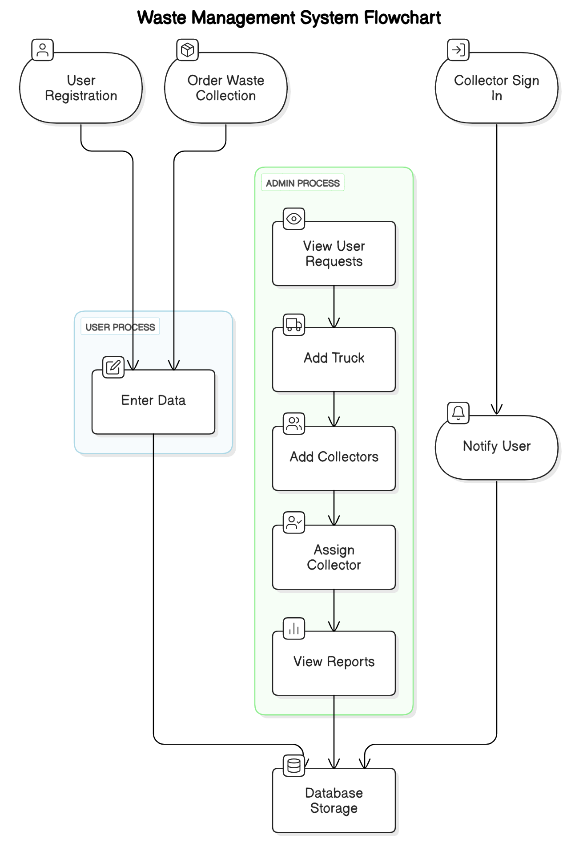
Figure 1 dfd

4.6.2 Use Case Diagram
The use case diagram identifies interactions between users and system functionalities:
- Resident: Request waste collection, view status, make payments.
- Admin: Manage users, view reports, assign tasks.
- Collection Staff: View assigned routes, update service status.
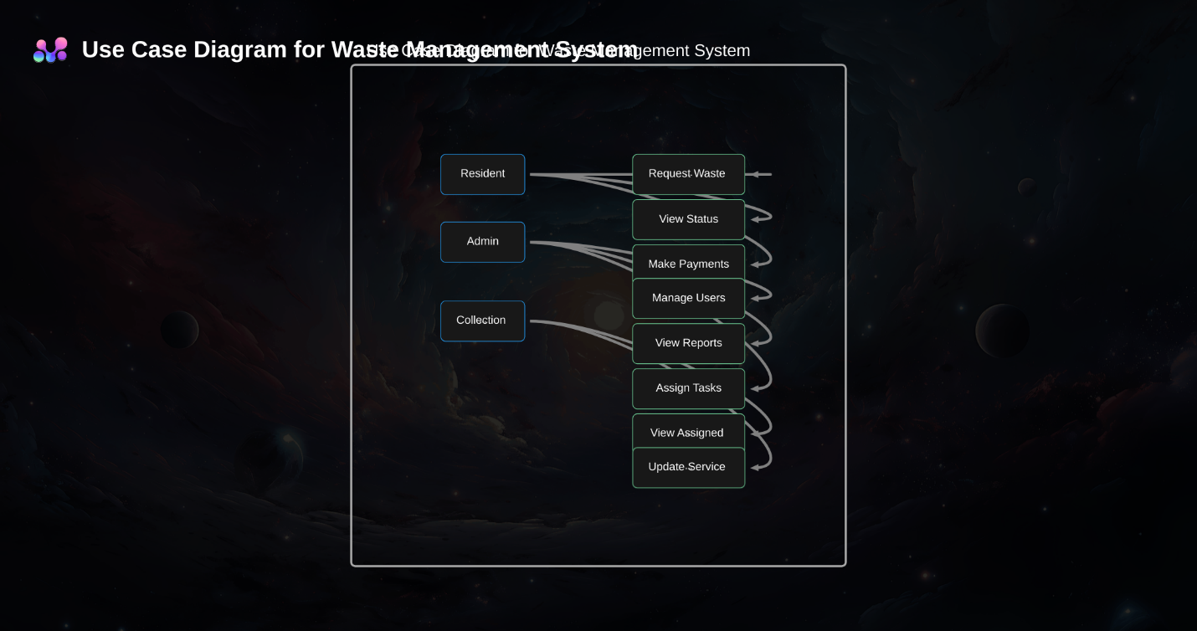
Figure 2 user case diagram

4.6.3 Interface Design
The system interface was developed for ease of use:
- Login Page for role-specific access
- Resident Dashboard: Request service, view bin levels, make payments
- Admin Dashboard: track progress, generate reports a assign tasks

4.6.4 Database Design
The database consists of structured tables:
Users Table: User details and roles
Table 1 users table
Field Name | Data Type | Description
user_id | bigint(20) | Unique user ID
username | varchar(50) | Username
password | varchar(30) | User password
email | varchar(50) | User email address
date | timestamp | Timestamp of last update/login

Collectors Table
Table 2 collectors table
Field Name | Data Type | Description
collector_id | bigint(20) | Unique ID for each collector
collector_name | varchar(50) | Name of the collector
password | varchar(20) | Password for login
collector_email | varchar(50) | Collector's email

orders Table: Waste collection requests

Table 3 orders table
Field Name | Data Type | Description
id | bigint(20) | Order ID (auto-increment)
phone_number | varchar(20) | Contact number of the user
location | varchar(30) | General location
user_id | bigint(20) | Linked user ID
house_address | varchar(40) | Detailed house location
collection_date | datetime | Date/time scheduled for collection
status | varchar(10) | Status of the order (e.g., pending)
payment_code | varchar(30) | Payment transaction code
collection_status | varchar(10) | Status of garbage collection
vehicle_id | varchar(20) | Assigned truck/vehicle ID
collector_id | bigint(20) | Assigned collector ID
date | timestamp | Timestamp of the order

Trucks Table: trucks details
Table 4 trucks table
Field Name | Data Type | Description
vehicle_id | varchar(25) | Unique truck/vehicle identifier
collector_id | bigint(20) | ID of assigned collector
license_id | varchar(30) | Truck license identifier

Feedback table for communication
Table 5 feedback table
Field Name | Data Type | Description
id | bigint(20) | Feedback ID (auto-increment)
user_id | bigint(20) | ID of the user submitting feedback
email | varchar(50) | User's email address
info | varchar(1000) | Feedback message
reply_status | varchar(15) | Status of the reply (e.g., replied)
reply | varchar(1000) | Response to the feedback

4.6.5 Reports
The system is equipped with a dynamic reporting module designed to enhance transparency, accountability, and decision-making in waste management operations. Reports are generated automatically and can also be filtered by user role, date, location, or status.

Collection Report
Purpose: Tracks waste collection activities by location, vehicle, and collector.
Details Captured: Collection ID, Date, Collector Name, Location, Status (Completed/Pending/Skipped), Truck Used.
Use Case: Helps administrators monitor performance and spot inconsistencies or missed pickups.
Payment Report
Purpose: Tracks all payments made by users for waste collection services.
Details Captured: Payment ID, User Name, Amount Paid, Payment Code, Payment Date, Status.
Use Case: Aids finance departments in reconciling revenues and identifying defaulters.
User Activity Report
Purpose: Logs actions performed by users and administrators in the system.
Details Captured: User ID, Activity Description (e.g., "Requested Collection", "Updated Route"), Timestamp.
Use Case: Useful for system audits, usage analytics, and identifying suspicious activities.
Feedback and Response Report
Purpose: Tracks user-submitted feedback and administrative responses.
Details Captured: Feedback ID, User Email, Message, Response Status, Reply Content.
Use Case: Improves customer service and provides insights into areas that need improvement.

CHAPTER 5: SUMMARY OF FINDINGS, CONCLUSIONS AND RECOMMENDATIONS

5.1 Introduction
This chapter provides a summary of the major findings from the research and development of the digital waste management system. It outlines key conclusions drawn from the system’s implementation and evaluation, and offers practical recommendations for future improvements and scalability. The goal is to ensure continuous enhancement of waste management practices through technology-driven solutions.

5.2 Summary of Findings
Findings indicate that integrating route optimization and real-time waste monitoring significantly enhances the efficiency of waste collection operations. User feedback highlighted the importance of notifications, scheduling options, and transparency in service delivery. The system was validated through user acceptance testing and showed high usability and functionality.

5.3 Conclusions
The study has demonstrated that digital transformation plays a critical role in enhancing the efficiency and sustainability of urban waste management. The integration of smart technologies such as route optimization algorithms, real-time data analytics, and digital payment systems has led to more organized and responsive waste collection operations. The following are the key conclusions:
Improved Waste Collection Efficiency:
The system streamlined scheduling and route planning, allowing waste collection vehicles to follow optimized paths. This led to faster waste collection and better coverage of underserved areas.
Enhanced Data Accuracy and Accessibility:
Through digitization, important records such as user profiles, collection logs, and payment histories were easily stored, retrieved, and managed. This reduced paperwork, minimized errors, and improved transparency.
Citizen Participation and Awareness:
By involving residents through service requests and notifications, the system promoted a sense of responsibility and participation in proper waste disposal practices. Users became more aware of waste collection schedules and their own waste generation habits.
Environmental Impact:
Timely collection and reduced illegal dumping contributed to cleaner urban environments, reducing pollution and health risks associated with unmanaged waste.

5.4 Recommendations
To further enhance the effectiveness and reach of the digital waste management system, the following recommendations are proposed:
Develop a Dedicated Mobile Application:
A user-friendly mobile app should be developed to allow residents to easily schedule pickups, make payments, report missed collections, and receive real-time updates. This would increase convenience and further encourage public engagement.
Integrate IoT Sensors in Smart Bins:
Embedding IoT-enabled sensors in public and residential waste bins can help monitor fill levels in real time. This data can be sent to the central system to further optimize routes, ensuring that bins are collected only when full and reducing unnecessary trips.
Expand Training for Staff and Users:
Training programs should be conducted for waste collection staff to familiarize them with the digital system. Additionally, awareness campaigns should be run for residents to promote adoption and usage of the system.
Implement Offline Support Features:
Given that some areas may face connectivity issues, the system should support offline data entry and later synchronization to ensure continued operations without interruptions.
Scale the System to Other Regions:
After successful implementation in the target urban area, the system can be replicated in other towns or counties facing similar waste management challenges. Customizations can be made to fit local contexts.
Strengthen Data Security Measures:
As the system deals with sensitive user data and financial transactions, additional layers of security, including two-factor authentication and regular audits, should be implemented to maintain trust and compliance.

References
Ahmad, R. W., Salah, K., Jayaraman, R., Yaqoob, I., & Omar, M. (2021). Blockchain for waste management in smart cities: A survey. IEEE Access, 9, 131520-131541.
Chowdhury, M., & Ali, R. (2024). IoT-Based Waste Collection Optimization: A Smart City Initiative. Journal of Urban Planning and Development, 50(3), 75-89.
Garcia, L., & Lee, H. (2024). Public Engagement in Waste Management: A Case Study of Digital Platforms. Waste Management Research, 39(4), 201-218.
Hassan, T., & Kumar, R. (2024). IoT-Enabled Waste Collection Systems for Urban Areas. Smart City Innovations, 30(1), 47-65.
Hernandez, P., & Chen, Y. (2024). The Role of AI in Waste Management: Trends and Challenges. Journal of Environmental Technology, 52(2), 90-110.
Kerdlap, P., Low, J. S. C., & Ramakrishna, S. (2019). Zero waste manufacturing: A framework and review of technology, research, and implementation barriers for enabling a circular economy transition in Singapore. Resources, conservation and recycling, 151, 104438.
Patel, K., & Nguyen, T. (2023). GIS and Smart Waste Collection: Improving Efficiency through Data Analytics. Sustainable Cities Journal, 28(4), 135-152.
Rodriguez, D., Zhang, L., & Li, X. (2024). Cybersecurity Challenges in Smart Waste Management Systems. International Journal of Smart Technology, 15(1), 55-72.
Sesay, R. E. V., & Fang, P. (2025). Circular Economy in Municipal Solid Waste Management: Innovations and Challenges for Urban Sustainability. Journal of Environmental Protection, 16(2), 35-65.
Singh, V., Ahmed, R., & Brown, S. (2023). Optimizing Waste Collection Routes Using IoT and GIS Technology. Journal of Waste Management, 37(1), 22-41.
Wang, K., Zhao, Y., Gangadhari, R. K., & Li, Z. (2021). Analyzing the adoption challenges of the Internet of things (Iot) and artificial intelligence (ai) for smart cities in China. Sustainability, 13(19), 10983.

Appendices
Appendix A: user manual
- Access the system via browser.
- Create an account and sign in.
- Order for waste collection. Fill in the needed details like location, phone number
- Make payments
- Wait for collectors’ notification.
Appendix B: admin manual
- log in to the system through the browser
- view the requested waste collection orders
- assign the orders to collectors and trucks to be used
- manage users, ie delete collectors and users, add collectors’ trucks and admin
Appendix C: System Screenshots
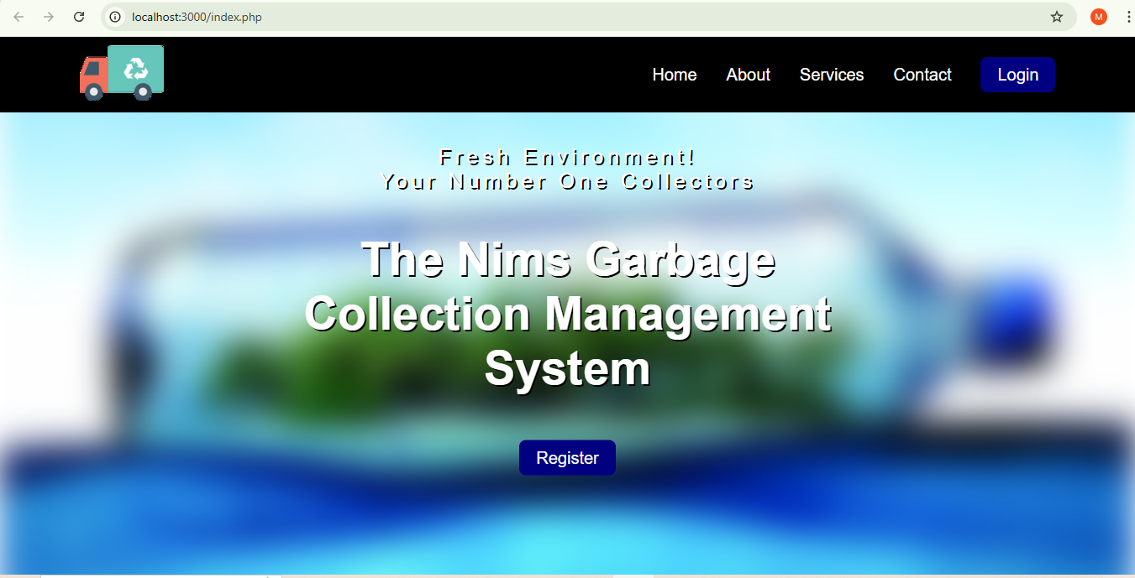

Figure 3 registration form
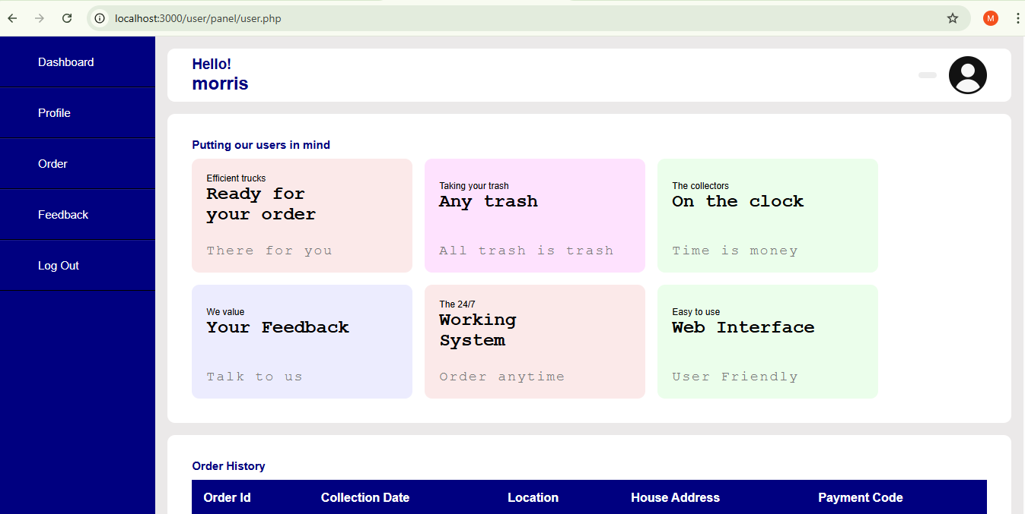
Figure 4 user dashboard
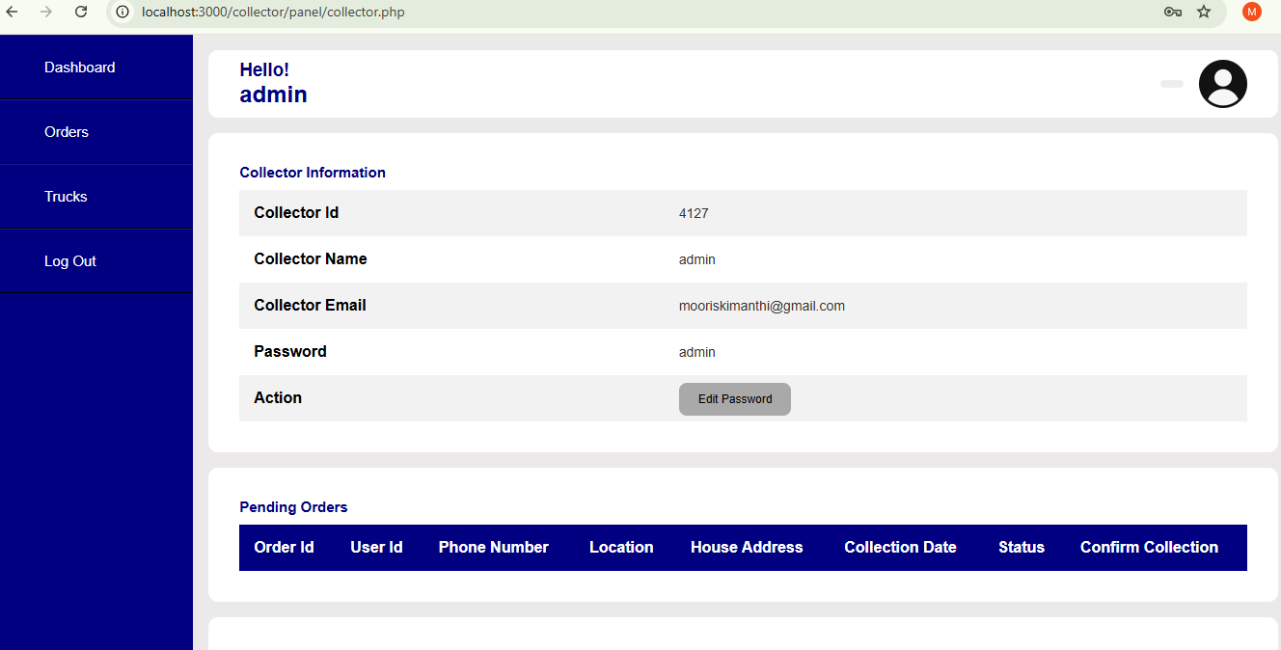
Figure 5 collector’s dashboard
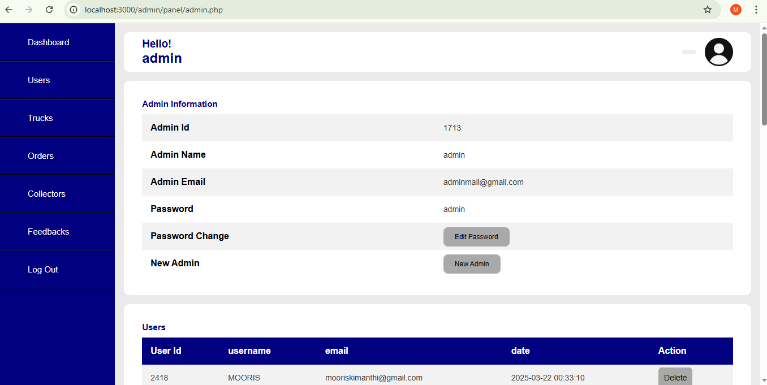
Figure 6 admin dashboard
Appendix D: Survey Questionnaires
Digital Waste Management Survey
Introduction:
Thank you for participating in this survey! Your responses will help us design a more efficient and user-friendly digital waste management system. Please answer the following questions based on your experiences and preferences regarding waste collection and disposal in your area.
1. How satisfied are you with the current waste collection system in your area?
- Very Satisfied
- Satisfied
- Neutral
- Dissatisfied
- Very Dissatisfied
2. How often do you find that your waste bin is not collected on time?
- Never
- Rarely
- Occasionally
- Frequently
- Always
3. Would you be interested in using a mobile app to track waste collection schedules, report full bins, and request pickups?
- Yes
- No
- Maybe
4. How important is it for you to receive notifications (e.g., reminders) about your waste collection schedule?
- Very Important
- Important
- Neutral
- Not Important
- Not Important at All
5. What features would you find most useful in a digital waste management system? (Select all that apply)
- Real-time updates on waste collection
- Notifications about upcoming pickups
- Ability to report missed pickups
- Option to schedule additional pickups
- Waste tracking for recycling purposes
- Payment processing for waste collection services
- Other (Please specify): ___________
6. Do you think that a smart waste bin (equipped with sensors to monitor fullness) would improve waste collection efficiency in your area?
- Yes
- No
- Not Sure
7. How likely are you to adopt a digital waste management solution that helps optimize waste collection routes and schedules?
- Very Likely
- Likely
- Neutral
- Unlikely
- Very Unlikely
8. Do you have any concerns about using digital technology for waste management?
- Yes (Please specify): ___________
- No
9. What would encourage you to engage more with a digital waste management system?
- Clear and easy-to-use interface
- Timely notifications
- Incentives or rewards for recycling
- Access to educational resources on waste management
- Other (Please specify): ___________
10. Any additional comments or suggestions for improving waste management in your area?
Conclusion:
Thank you for completing this survey. Your feedback is valuable and will be used to enhance the digital waste management system for your community.
These data collection methods ensure that both qualitative and quantitative data are used to inform the system’s design, ensuring that the solution is comprehensive and meets the needs of all stakeholders.
Appendix E: Gannt chart
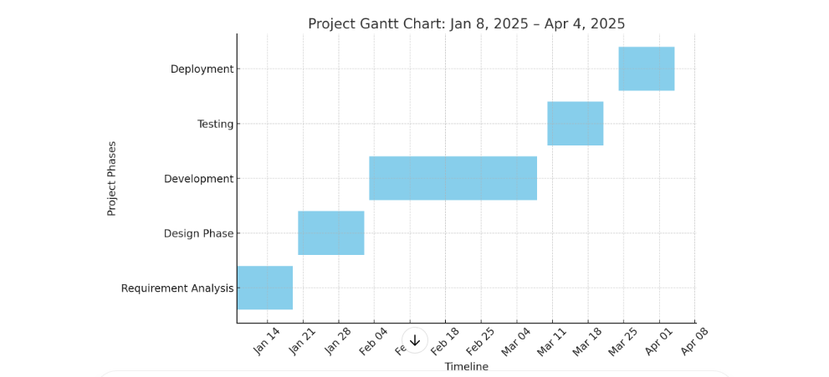
Figure 7 Gannt chart

Appendix F: Code
